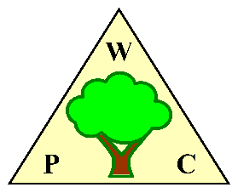
WOODPLUMPTON PARISH COUNCIL
AGENDA for MEETING TO BE HELD IN

THE PARISH ROOMS, REAR OF ST ANNE’S CHURCH WOODPLUMPTON ROAD, PRESTON

ON MONDAY 17th June 2024 at 7.00pm

- APOLOGIES
Members are reminded that apologies should be given in advance of the meeting and will be noted in the Minutes. If a Councillor is absent for 6 consecutive months, an apology must be approved by the Council, prior to the 6 months elapsing or the Councillor will be disqualified. Members are requested to note any given apologies for the June meeting.
- APPROVAL OF THE MINUTES of the Parish Council Meeting held on 20th May 2024.
The Chairman is required to sign the Minutes as a true record.
- TO ACCEPT DECLARATIONS OF INTERESTS AND TO CONSIDER ANY WRITTEN REQUESTS FOR DISPENSATIONS
Members are reminded of their responsibility to declare any interests in respect of matters contained in the agenda. A Councillor with a disclosable pecuniary interest or any other interest, as set out in the Council’s Code of Conduct, is subject to statutory restrictions on the right to participate and vote on that matter – see Standing Order 2020 (13)
Any alterations to declarations of interest made throughout the municipal year, must be submitted to the Clerk, to be forwarded to the Monitoring Officer within 28 days of the change occurring.
Councillor John Green declares an interest in item 15 Broughton High School as he is a member of the Broughton High School PTFA.
- PUBLIC PARTICIPATION
Members of the public wishing to raise matters in accordance with Standing Order 2020 (3g & h), should raise them here. The length of the adjournment will be at the Chairman’s discretion. Matters requiring a Council decision must be included as a specific Agenda item.
An invitation to attend has been sent to the Police, County and City Councillors.
Following any other items raised by the public, the meeting will be reconvened and any decision taken by the Council will be documented under the agenda item.
- NEWSHAM HALL / WOODPLUMPTON ROAD JUNCTION AND WHITTLE HILL
The Parish Council has placed orders for signs to warn drivers on the approaches to the junction and for 2 SPIDs to indicate the speed of vehicles as they approach the junction from either side.

The LCC monitoring period for the junction runs until the end of June 2024, therefore they will provide no further update until this period has expired.

- CONSULTATION ORCHARD PLAY AREA.
Work is progressing on the Orchard parking scheme, with the next step being an onsite meeting to consider possible options.

- CATFORTH TRAFFIC CALMING SCHEME
The latest update is that TROs are being prepared and will be issued in around 6 weeks.

- LINEAR PARK
There is no further information regarding the Linear Park. My request to Planning regarding whether we can invest in items within the park or my subsequent request for a meeting has not been responded to.
I have received feedback from PCC on the flow of CIL money.

- FINANCIAL STATEMENT 31 May 2024
Members are requested to NOTE the May Precept receipt of £48,065 and VAT reclaim for 2023/4 of £2,781.31.

The Chairman is requested to confirm the parish account statement has been verified with the End of May Bank statements. (Docs attached)

The End of May Balances were:
Current Account £152,813.31
CCLA Account £297,742.38

- ACCOUNTS FOR PAYMENT AND RECEIPTS 30 June 2024
Members are requested to note and approve the following accounts already paid after the May meeting in accordance with Standing Order 15 (b) xii
DETAILS | PAYEE | AMOUNT | REF
May payments Prior to Meeting
Lengthsman Invoice May 2024 | Lengthsman | £1520.00 | Ref 30
Lengthsman Expenses May 24 | Lengthsman | £8.99 | Ref 31
Purchase of Maps for Bins | PCC Sundry Debts | £89.35 | Ref 32
WPC Insurance | Clear Councils | 549.09 | Ref 33
Pension Payment Clerk | NEST | 59.13 | Ref 34
SPID Purchase Newsham Hall Lane | Traffic Technology | 7732.80 | Ref 35
Garden Invoice May 2024 | Lengthsman | 326.48 | Ref 36
Repair to Hedgetrimmer | Lengthsman | 135.63 | Ref 37
Printer Purchase | Viking Direct | 454.80 | Ref 38
Posts for SPIDs N Hall Lane | Lancashire CC | 957.60 | Ref 39

- ACCOUNTS FOR PAYMENT AND RECEIPTS
Members are requested to approve the following accounts for payment

Clerk Salary June 2024 | £773.54 | BACs
HMRC PAYE | £557.33 | BACs
Employer National Insurance | £83.72 | BACs
Pension contributions clerk June 2024 | £59.13 | DD
 |  | BACs
 |  | BACs
 |  | BACs

- Bowser Purchase
The Council proposes to purchase the water bowser described below, for the watering of planters once these are in place. The Bowser has a gross weight of 750Kg making it suitable for towing with a lightweight vehicle.

The Bowser can be stored at the clerks property if required.
500 Litre Highway Tow Potable Water Bowser  Extended Chassis  + 1” Petrol Pump  15ft hose on a post  Total Delivered cost £3359+vat – customer to offload | 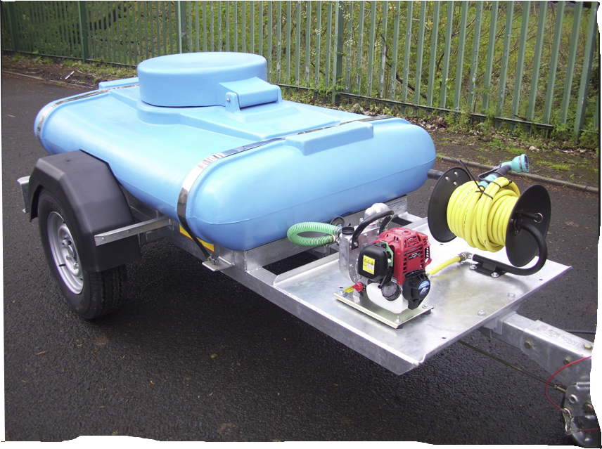
The purchase will only be made once we are progressing towards purchasing planters.

- WARDING ASSESSMENT
Warding assessment team to provide an update to the council.

- NEW ESTATES MAINTENANCE
Cllr John Green and the Clerk to provide an update.

- REQUESTS FOR SUPPORT

Broughton High School
Councillor Green has spoken to Broughton High School. They are looking for some help with a number of Canopies that they want to build around the school site.
Whilst the school is technically outside the parish, a large proportion of the parish’s secondary school children attend the school.

The school’s comments:

"There are numerous areas where we have circular eight seater picnic tables available, not all are under canopies meaning that when we have inclement weather these tables cannot be used. It would enhance our site considerably and mean that, when it is wet, pupils do not have to rely on staying in busy indoor dining areas to stay dry. It also means that the distribution of pupils across the school site is more even for staff on duty. We would welcome the opportunity to show members of the Parish Council our wonderful site, should they wish to visit school."
They are looking to build a number of canopies each costing approximately £15k dependant on size and would like to ask the parish if they'd be prepared to fund one or more of these for the school.

Ribbleswood Bridge
PCC have provided a rough estimate of £15,077 for the replacement of the Ribbleswood Bridge. The cost of the replacement bridge will be paid from CIL money. If the cost is acceptable then the PCC will put the work out to tender and proceed. The Council is invited to approve proceeding with the replacement of the Bridge at a cost of up to £25,000 with the final figure being confirmed once tenders are received.

- GRIT BINS
LCC have advised that the 2 new Grit Bins located on Roots Lane Catforth & outside the Mortuary on Hollowforth Lane will not be added to their schedule to be filled & replenished. They have advised that we can pay £40 per filling (typically 3 – 4 times a year).

- Do we want to retain them at our expense?
- Are there any other locations where additional grit bins are required?
(There is an LCC scoring process to determine if a location meets the requirements for a bin at their expense, if it doesn’t, we would have to fund them at our expense.

- RED TELEPHONE BOXES
Members are requested to consider whether to purchase any Red Telephone boxes at an approximate cost of £2,000 - £3,000 each. If such a purchase is to be made a location and a purpose for the boxes will be required.

- WOODPLUMPTON FETE
Councillor Pauline Bamber to provide an update on the Woodplumpton Fete.

- PLANNING APPLICATIONS BEFORE COUNCIL
Members are requested to consider and approve the attached delegated comments for February. Applications can be viewed at www.preston.gov.uk
- BINS AND PLANTERS AROUND THE PARISH
Considerable progress has been made on the purchase and placement of Bins. We are awaiting the final cost estimate before placing orders. The Council approved the purchase of up to 25 bins at a cost of £450 each, giving a total expenditure of £11,250 at the May meeting. It is proposed that Bins will be labelled

“Woodplumpton Parish Council in Partnership with Preston City Council”
This I believe rightly recognizes that the Parish Council will pay for the Bins and PCC will then provide the ongoing service.

Work on the siting of planters will commence now that the work to install bins has been completed and is with PCC to finalize then implement.
- UPDATE ON ISSUES FOR INFORMATION

- DATE OF NEXT MEETING
Members are requested to note that the next meeting is scheduled to take place on Monday 8th July 2024 at 7.00 in the Parish Rooms.

END

